CMSK 14022 - Photography for Social and Emotional Learning
Student Number EC/2021/005
Assignment 02
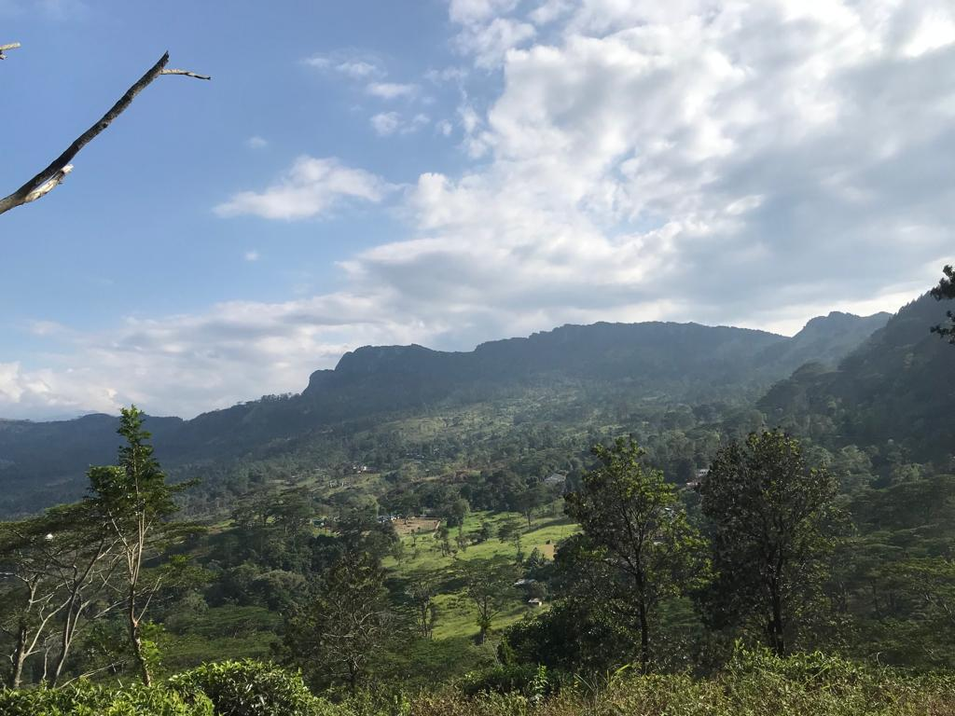
The photograph of a mountain range at dawn, shrouded in a light mist, stirred feelings of peace and renewal in me. The soft morning light gently touches the peaks, casting a warm, golden glow that contrasts beautifully with the cool, bluish mist rolling over the slopes. This interplay between light and shadow creates a sense of mystery and tranquility, as if the mountains are slowly awakening to a new day. What drew my attention most was the calm stillness of the scene; the mist seemed to soften the rugged landscape, making it look almost ethereal. It reminded me of nature’s quiet strength and the sense of possibility that each morning brings. This image captured the delicate balance of serenity and power found in the mountains, evoking both admiration and a feeling of peaceful introspection.

